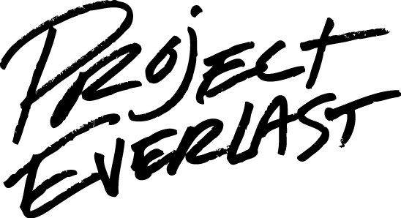
Membership Engagement/Recruitment Worksheet
Instructions: This worksheet can be used to develop a plan for engaging new members and/or building increased involvement/development of current members. It is important to complete a separate worksheet for recruitment and retention, as many of components may be different.
- Select whether focusing on Recruitment or Engaging current members.
- Fill in each tile based on your council’s as it exists now.
- Utilize the results to develop strategies for overcoming barriers, developing new opportunities and exploring the power of current efforts.

Current Activities | Activities that are Missing
Opportunities to Enhance Current Efforts | Barriers

